IOR RACHP Engineering Technicians Section
Lifetime Achievement Award Nomination Form

Make your nomination now
Nominations may be made by employers, clients or colleagues. Candidates must have substantial experience as a service, maintenance or installation technician and be active in a field-based role in the UK.

Return this completed form to ior@ior.org.uk or contact us if you have any queries.

Details of the person making the nomination
Name
Company
How do you know  the candidate? | Employer  Client  Other (please describe):
Phone number
Email address

I would like to nominate the following person for the Lifetime achievement award
Name
Company
Contact address

Email
Phone number
if known

Nomination Statement ‐ Please make a statement either here or on attached notes outlining why you think this person should be considered for a Lifetime Achievement Award. Please answer the point below.
This person should be considered for the lifetime achievement award because:
Please provide one or more examples of what this individual has done that makes them stand out?
How have they shown their commitment to the industry, beyond their length of service?
Other comments you would like to make in support of your nomination

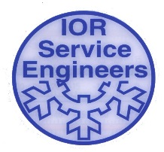
If have any questions about the nomination process, please contact lisa@ior.or.uk

